EXOTHERMIC AND ENDOTHERMIC PROCESSES

Aim: To observe some exothermic (heat releasing) and endothermic (heat absorbing) processes.

Method:

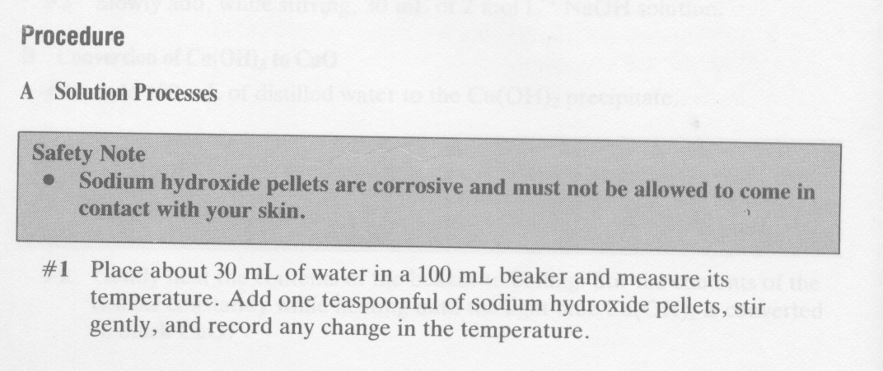
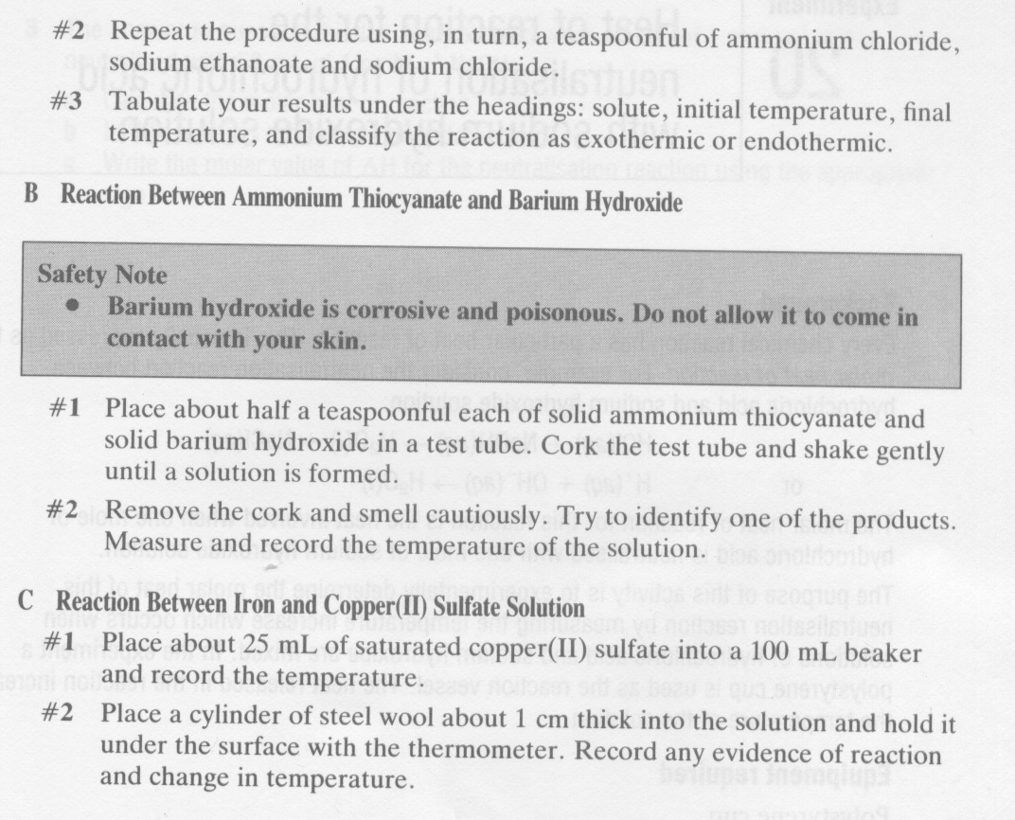

Results:

REACTION | OBSERVATIONS
A: Dissolving sodium
hydroxide (NaOH)
B: Reaction between
ammonium thiocyanate
+ barium hydroxide
C: Reaction between iron +
copper sulphate

Conclusion: Determine whether the reactions are exothermic or endothermic.

